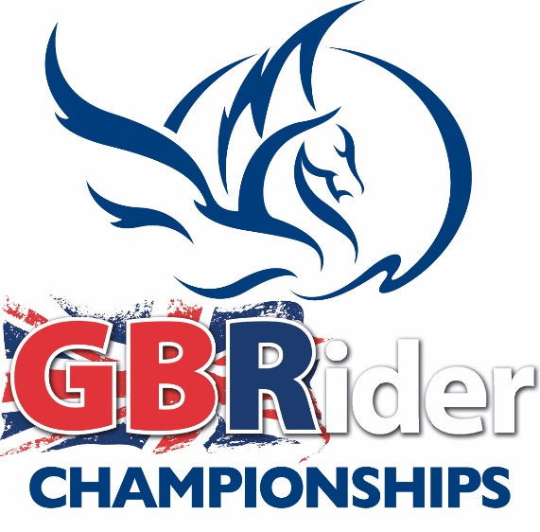

Rules for GB Rider Showjumping Qualifiers 2018

Championships for Showjumping to be held at Bury Farm Equestrian Centre on the 2nd September 2018.

Riders must buy their membership numbers from GB Rider prior to the competition at a cost of £20 when purchased on line by visiting http://www.gb-rider.com/webshop/memberships/

Qualification cards are sent in the post. If you need your number urgently ring 01234 211245
Riders cannot qualify if they do not have a membership number.

Please note: Horse/pony combinations cannot enter more than two classes and they must be consecutive. ie mini and novice, novice and small open, small open and open except for non- championship classes.

Mini Individual

- The Finals will be 70cm in the first round. The Qualifiers may be 65cm but not lower
- The competition is open to all horse/pony and rider combinations who have not won any notional money BS on the date of the show at which they qualified. Any winnings subsequent to qualifying will not be taken into account.
- First, second and third places qualify. i.e. 6 per class (3 horses and 3 ponies)
- If first, second and third places do not have a membership number, the qualification can pass down the line as far as 5th place.
- All horses and ponies must go clear in the first round in order to qualify.

Novice Individual

- The Finals will be 80cm first round. The Qualifiers may be 75cm but not lower
- This competition is open to all horse/pony and rider combinations who have not won a total of 49 points or £49 (notional) BS on the date of the show at which they qualified. Any winnings subsequent to qualifying will not be taken into account.
- First, second and third places qualify. i.e. 6 per class (3 horses and 3 ponies)
- If first, second and third places do not have a membership number, the qualification can pass down the line as far as 5th place.
- All horses and ponies must go clear in the first round in order to qualify.

Small Open Individual

- The Finals will be 90cm first round. The Qualifiers may be 85cm but not lower
- Open to all Horse/Pony and Rider combinations who have not won more than 99 points or £99 (notional) BS prize money on the date of the show at which they qualified. Any winnings subsequent to qualifying will not be taken into account.
- First, second and third places qualify. i.e. 6 per class (3 horses and 3 ponies)
- If first, second and third places do not have a membership number, the qualification can pass down the line as far as 5th place.
- All horses and ponies must go clear in the first round in order to qualify.

Open Individual

- The Finals will be 1m first round. The Qualifiers may be 95cm but not lower
- This competition is open to all horses/ponies.
- First, second and third places qualify. i.e. 6 per class (3 horses and 3 ponies)
- If first, second and third places do not have a membership number, the qualification can pass down the line as far as 5th place.
- All horses and ponies must go clear in the first round in order to qualify.

Secretaries/Show Organisers please note:

REMEMBER - Show secretaries do not need to send the results back to GB Rider As Showjumping members will be issued with a qualification card which they must get signed by the show secretary on the day of the show when they qualify.

The Qualifying Show Entry form and Results Sheet must have a column where the rider can enter their GB Rider membership number.
Riders cannot qualify unless they have a valid membership number for the 2018 season

Qualifying Courses

All qualifying courses must include:
  - at least one double
  - at least two parallel fences
  - at least eight fences
  - at least two fillers
  - they must be built up to the heights specified

Shows can run qualifiers under BS, Riding Club or Pony Club rules.

RULES & RESTRICTIONS FOR THE GB Rider CHAMPIONSHIPS @ BURY FARM 2nd September 2018.
The spirit of this competition as an amateur & unaffiliated championship is very important to us as organisers, to our sponsors and to our competitors, so we request that all participants respect the spirit of restrictions not just the letter of the law. If you find that you are overqualified for the class that you qualified in, you can voluntarily upgrade to a higher level class. Horses/riders that have more than the allowed points or placings, but NONE earned in the previous 3 years (from 25th March 2018) are eligible to compete.
MINI INDIVIDUAL:
65cm - 70cm Classes: In the past 3 years from 25th March 2018, horses/ponies not to have won a total of 19 points or £19 (notional) Prize money, not to have earned any BE points or foundation points. Combination not to have competed in BS competitions at 80cm or above or any BE events, except on a day ticket or at BS Club; not to have competed in Pony Club or Riding Club Area Intermediate Championship level show jumping or eventing.
NOVICE INDIVIDUAL:
75cm - 80cm Classes: Horses/ponies – not to have won a total of 49 points or £49 (notional) prize money in BS, not to have earned any BE points or more than 49 BE Foundation points (or none within the past 3 years from 25th March 2018). Combination not to have competed in BS classes at 1m or above; not to have competed at BE 100 or Pony Club Area Intermediate Eventing or Show Jumping or above.

SMALL OPEN
85cm - 90cm Classes: Horses/ponies – not to have won 99 points or £99 (notional) prize money or points in BS or more, not to have earned 10 BE points or 99 BE foundation points (or none within the past 3 years from 25th March 2018). Combination not to have competed in BS classes at 1.10m or above; not to have competed at BE Novice or Pony Club Open Eventing or Show Jumping or above.
OPEN
95cm - 1m Classes: Horses/ponies – Open to all COMBINATIONS.

